6  AD DATES:  Monday, May 11th  Sunday, May 17th  HOME DELIVERIES:  Wednesdays; $5.00  SENIOR CITIZEN DAY:  Wednesdays | 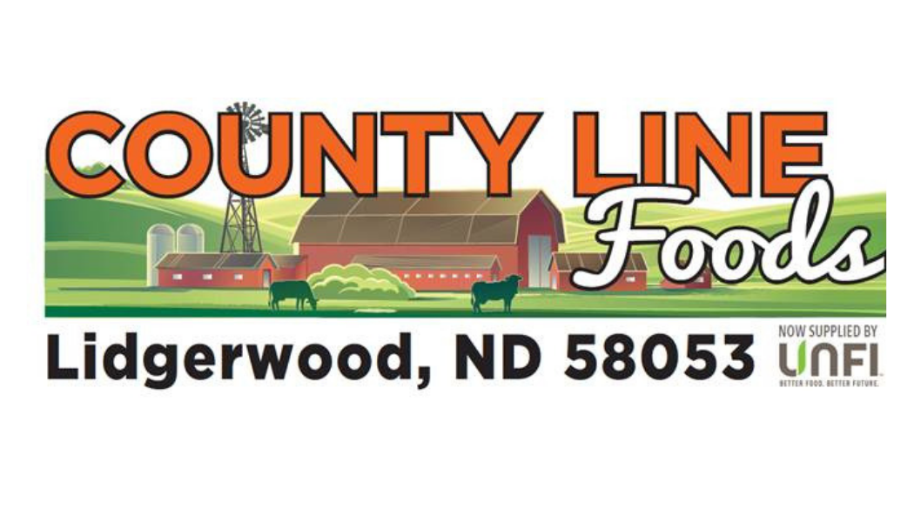 | STORE HOURS:  Monday – Friday  7am – 7pm  Saturday  8am – 6pm  Sunday  9am - 1pm  Call us at:  701-538-9837

Cosmic Crisp Apples  $1.99/lb. | Clamshell Blueberries  $2.99 | Pears  $1.49/lb.
Peaches  $3.99/lb. | Cucumbers  $0.79 | Lettuce  $1.99
Green Peppers  $0.79 | Colored Peppers  3/$4.00 | Taylor Farms Snappers  $2.99
Taylor Farms  Brussel Sprouts  $2.99 | Assorted Fresh Express Salads/Greens  2/$5.00 | Essential Every 32oz Shredded Cheese  $8.99
Kraft 8oz Grated Parmesan Cheese  $4.59 | Essential Everyday Whole Milk Ricotta  $2.49 | Essential Everyday Whipping Cream  $3.29
Essential Everyday 8oz Sour Cream  $0.99 | Starbuck’s 40oz Coffee  $6.49 | Reddi-Whip  $2.99
5.3oz Oikos Yogurt  $8/8.88 | Kemps Sherbert  $3.99 | Kemps Ice Cream  $3.99
Kemps Ice Cream Sandwiches  $5.99 | Essential Everyday Frozen Fruit  $3.99 | Essential Everyday Frozen Orange Juice  $2.99
4ct Drumstick Cones  $4.99 | Banquet Meals  2/$4.00 | Hungry Man Dinners  2/$8.00
Marie Callender Bowls  2/$6.00 | Marie Callender Pot Pies  2/$6.00 | Tombstone Pizza  2/$8.88
Birds Eye Vegetables  3/$4.00 | Essential Everyday Vegetables  2/$3.00 | Essential Everyday 10oz Steak Sauce  $2.99
14oz Heinz Mustard  $1.69 | 20oz Hunt’s Ketchup  2/$3.00 | Kraft Barbeque Sauce  $1.69
Heinz Cocktail/Chili Sauce  $3.29 | Essential Everyday 28oz Peanut Butter  $3.99 | Essential Everyday 30oz Mayo  $3.99
Milwaukee Pickles  2/$6.00 | Vlasic Pickles  2/$6.00 | Hidden Valley Ranch  $3.99
Wishbone Dressing  2/$5.00 | Starkist Tuna Pouches  4/$5.00 | Manwich  2/$3.00
Essential Everyday Baked Beans  $2.29 | Essential Everyday Canned Vegetables  4/$3.00 | Betty Crocker  Fruit Snacks  $2.99
General Mills Cereal  2/$6.00 | Cheez-Its  $3.29 | Club Crackers  2/$7.00
Essential Everyday Oatmeal  $2.99 | Mrs. Butterworth’s Syrup  $3.69 | Nabisco Chicken In A Biscuit Crackers  $4.99
Log Cabin Syrup  $3.69 | Snack Pack Pudding  2/$3.00 | Pam Cooking Spray  $3.49
Betty Crocker  Cookie Mix  $3.49 | Essential Everyday Graham Cracker Crust  $2.29 | Essential Everyday Marshmallows  $1.99
Essential Everyday Glass Cleaner  $3.99 | Essential Everyday Dish Detergent  $2.49 | Superchill Club Soda/Tonic Water  $0.99
Superchill 12pks  $5.99 | Charmin Bath Tissue  $5.99 | Jolly time Popcorn  $4.99
CHECK OUT OUR BAKERY ITEMS |  | CHECK OUT OUR OFF-SALE
Boneless Angus  Sirloin Tip Steak  $7.49 lb. | Wholestone  Pork Back Ribs  $3.99 lb. | Boneless Angus  Sirloin Tip Roast  $6.99 lb.
Hormel Cure 81  Boneless ¼ Hams  $4.99 lb. | Curly’s BBQ  Pork Ribs  $13.99 oz | Oscar Mayer Asst.  Sliced Bacon  $5.99 16oz
Grillo’s Refrigerated  Pickles  $5.99 32oz | Cowboy Jack’s  Beef Patties  $10.99 32oz | Arctic Shores  Pollock Fillets  $3.99

THANK YOU FOR SHOPPING LOCAL!

