6  AD DATES:  Monday, June 8th  Sunday, June 14th  HOME DELIVERIES:  Wednesdays; $5.00  SENIOR CITIZEN DAY:  Wednesdays | 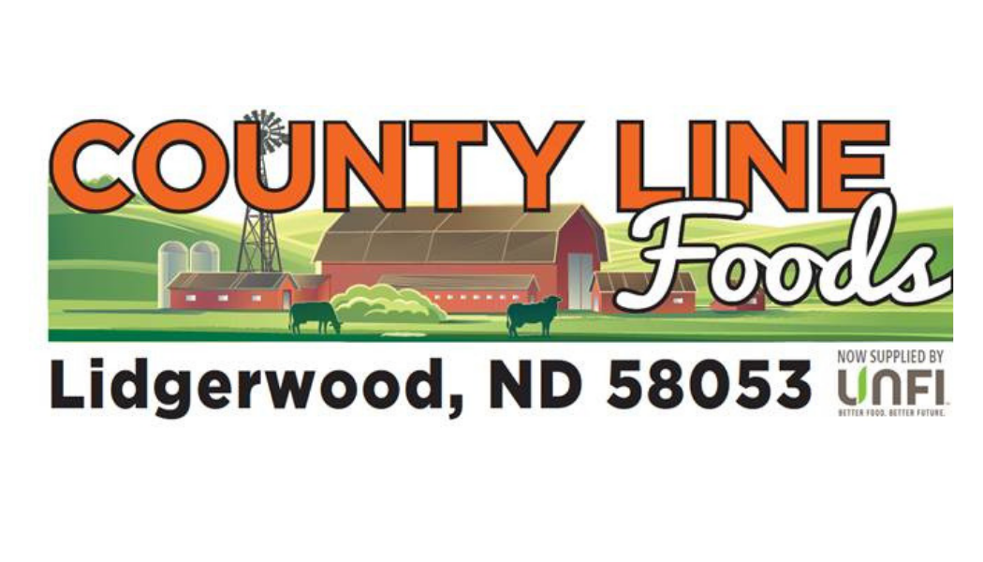 | STORE HOURS:  Monday – Friday  7am – 7pm  Saturday  8am – 6pm  Sunday  9am - 1pm  Call us at:  701-538-9837

Peaches  $2.99 | Nectarines  $2.99 | Fresh Express Blends  2/$5.00
Taylor Farms Snow Peas  $2.99 | Taylor Farms Brussel Sprouts  $2.99 | Cauliflower  $3.49
Corn  4/$2.00 | Vidalia  $0.99/lb. | Green Peppers  $0.99
Essential Everyday Cheese  2/$4.00 | Essential Everyday Cheese Sticks  $3.29 | Crystal Farms  Sliced Cheese  $3.49
I Can’t Believe  It’s Not Butter  $3.49 | Essential Everyday Cottage Cheese  2/$6.00 | Yoplait Whips  10/$6.00
Essential Everyday  Almond Milk  $2.99 | Essential Everyday 16oz Sour Cream  2/$4.00 | International Delight Coffee Creamer  $2.99
45oz Country Crock  $5.99 | Essential Everyday Butter  $2.99 | Bay’s English Muffins  2/$6.00
Essential Everyday  Jumbo Biscuits  2/$5.00 | Stoneridge 12ct Ice Cream Bars  $4.99 | Stoneridge 12ct Fudge/Orange Dream Bars  $3.99
Stoneridge Ice Cream  2/$7.00 | Totino’s Pizza Rolls  $4.99 | Mars 6pk Ice Cream Bars  $4.99
Essential Everyday  Frozen Blueberries  $8.99 | Essential Everyday 5 Cheese Texas Toast  $3.49 | Eggo Waffles  2/$6.00
Essential Everyday  30oz Mayo  $3.99 | Essential Everyday 24oz Squeeze Ketchup  $0.99 | Essential Everyday  Pasta Sauce  2/$4.00
Starkist Chunk Tuna  3/$3.00 | Essential Everyday  Fruit Cups  2/$5.00 | Mott’s 6pk Apple Sauce  $3.49
Creamette Pasta  $0.99 | Essential Everyday  Pork & Beans  $0.99 | Ortega Taco Sauce  2/$6.00
Essential Everyday Instant Oatmeal  $3.29 | Pearl Milling Company Syrup/Pancake Mix  $3.49 | Family Size  Townhouse Crackers  $5.99
Post Cereal  $3.99 | Kellogg’s Special K  3/$13.00 | Maruchan 6pk Ramen  $1.99
Essential Everyday  Oyster Crackers  $1.99 | Essential Everyday  Olive Oil  $5.99 | 6pk San Pellegrino  $6.49
Essential Everyday Cranberry Juice  $2.69 | Essential Everyday Cooking Spray  $2.69 | Essential Everyday  Quart Freezer Bags  $4.99
Essential Everyday Bleach  $4.99 | Palmolive Dish Soap  $2.99 | Charmin Bath Tissue  $5.99
Gardetto’s  2/$5.00 | Hershey Pouches  $6.49 | Lay’s Stax  2/$4.44
Chex Mix  2/$5.00 | Bugles  2/$5.00
CHECK OUT OUR BAKERY ITEMS | 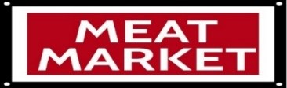 | CHECK OUT OUR  OFF-SALE
Boneless Angus  Bottom Round Steak  $6.99 lb. | Tyson Whole  Chicken Wings  $1.99 lb. | Boneless Angus  Bottom Round Roast  $6.79 lb.
Hillcrest Bone-In  Smoked Pork Chops  $7.49 lb. | Wholestone Boneless  Pork Sirloin Roast  $2.19 lb. | Arctic Shores  Cod Fillets  $9.99 16oz
Oscar Mayer  Beef Hot Dogs  $5.99 16oz | Arctic Shores 26/30  Easy Peel Raw Shrimp  $8.99 16oz | Oscar Mayer  Stuffed Hot Dogs  $4.99 16oz
Banquet  Brown-n Serve Sausage  2/$4.00 6.4oz | Tyson Breaded  Chicken Snacks  $6.99 23-29oz | Bar-S  Classic Corn Dogs  $8.99 2.67 lb.

THANK YOU FOR SHOPPING LOCAL!

